Module 2: EC2 and EFS Assignment

Tasks To Be Performed:

Creating two SG: one for default vpc allowing ssh and second one for EFS: allowing NFS in inbound for EC2 security group. 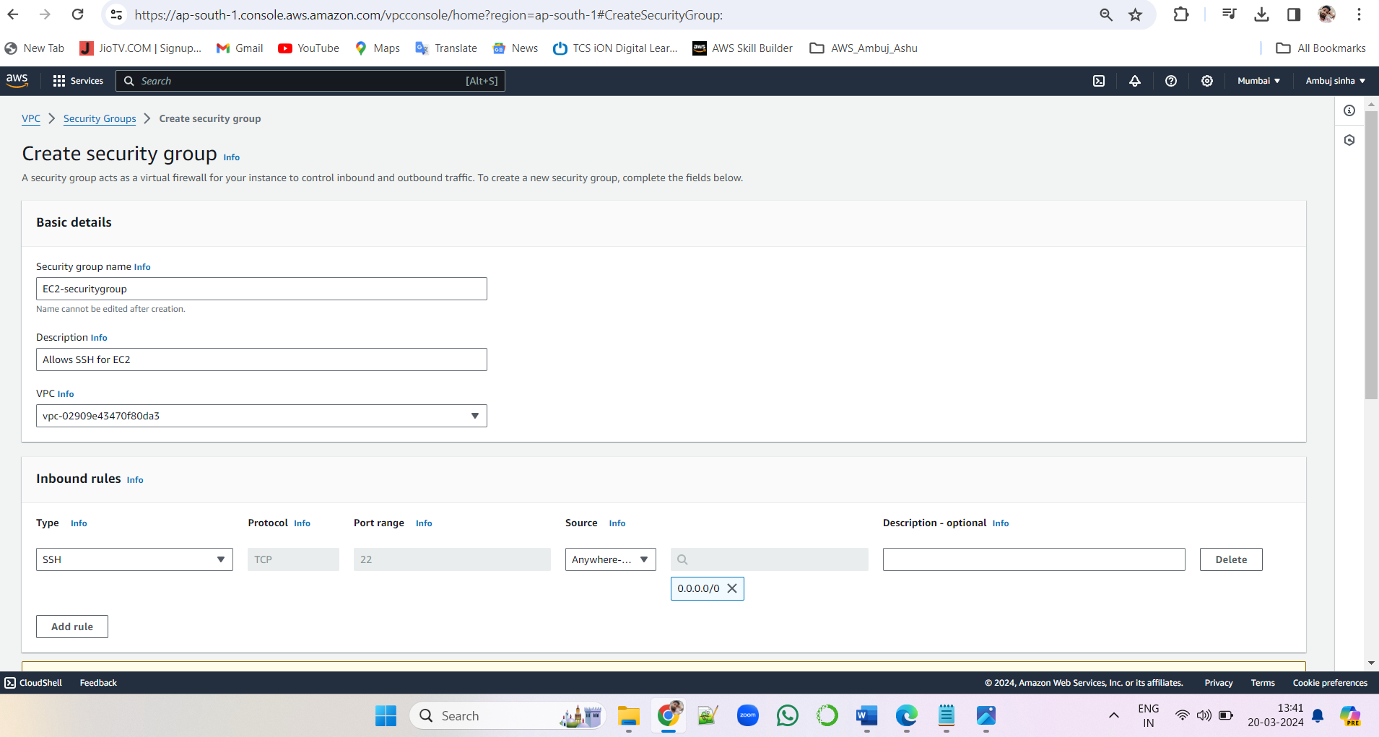

1. Create an EFS and connect it to 3 different EC2 instances. A screenshot of a computer

   Description automatically generatedA screenshot of a computer

   Description automatically generatedA screenshot of a computer

   Description automatically generatedA screenshot of a computer

   Description automatically generated
2. Make sure that all instances have different operating systems.
3. Ubuntu, A screenshot of a computer

   Description automatically generatedA screenshot of a computer

   Description automatically generatedA screenshot of a computer

   Description automatically generatedA screenshot of a computer

   Description automatically generated
4. Red Hat Linux A screenshot of a computer

   Description automatically generatedA screenshot of a computer

   Description automatically generatedA screenshot of a computer

   Description automatically generatedA screenshot of a computer

   Description automatically generated
5. and Amazon Linux 2. A screenshot of a computer

   Description automatically generatedA screenshot of a computer

   Description automatically generatedA screenshot of a computer

   Description automatically generatedA screenshot of a computer

   Description automatically generated

checked with ubuntu:

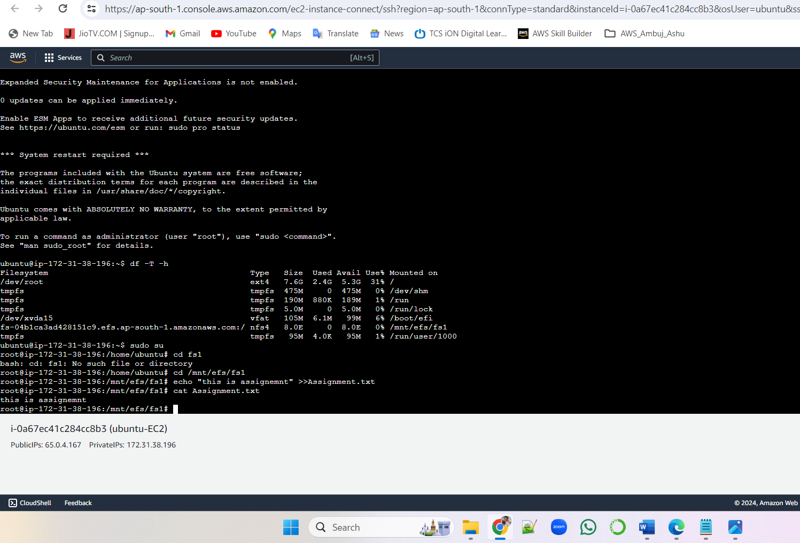

Checked with linux:

Checked with redhat:

